Practical – 7
Aim of the Practical :- To analyze network traffic using Wireshark –
capture ICMP packets and study their header fields.

Objectives
1. To capture and study ICMPv4 packets using Wireshark.
2. To understand how ping utility generates ICMP packets.
3. To identify and interpret the key fields in the ICMP header.
4. To observe Echo Request, and Echo Reply, and messages.

Introduction :-
The Internet Control Message Protocol (ICMP) is used by network devices to send error messages and operational information.
One common use of ICMP is the ping command, which sends an Echo Request to a host and waits for an Echo Reply.
By capturing these packets in Wireshark, we can see how ICMP works at the network level.

Terminology :-

Ping: A utility that tests connectivity between two devices by sending ICMP Echo Requests.
ICMP Packet: A message used for diagnostics and error reporting in IP networks.
Echo Request (Type 8): A message sent by the source device to test reachability.
Echo Reply (Type 0): A response from the destination device confirming receipt.
Checksum: A value used to detect errors in the packet.
Sequence Number & Identifier: Fields that help match requests with replies.
Round-Trip Time (RTT): Time taken for a packet to go from source to destination and back.

Procedure:-
- Start Wireshark and select the active network interface (like Wi-Fi or Ethernet).
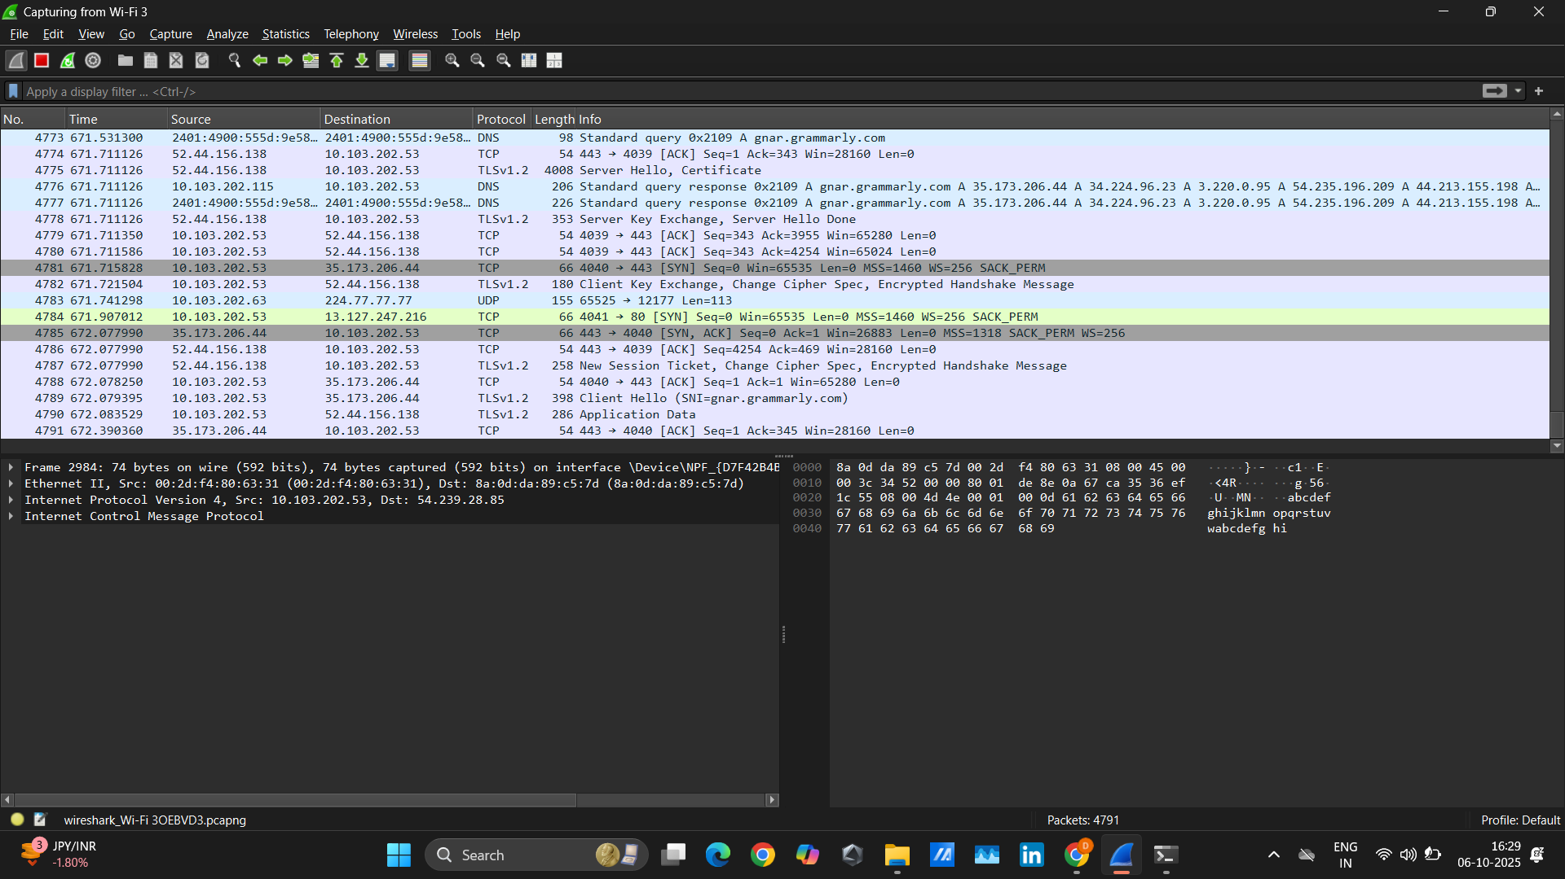
- Begin capturing packets

- Open Command Prompt and type
ping <hostname or IP address>
- i ping 54.239.28.85(Amazon.com)

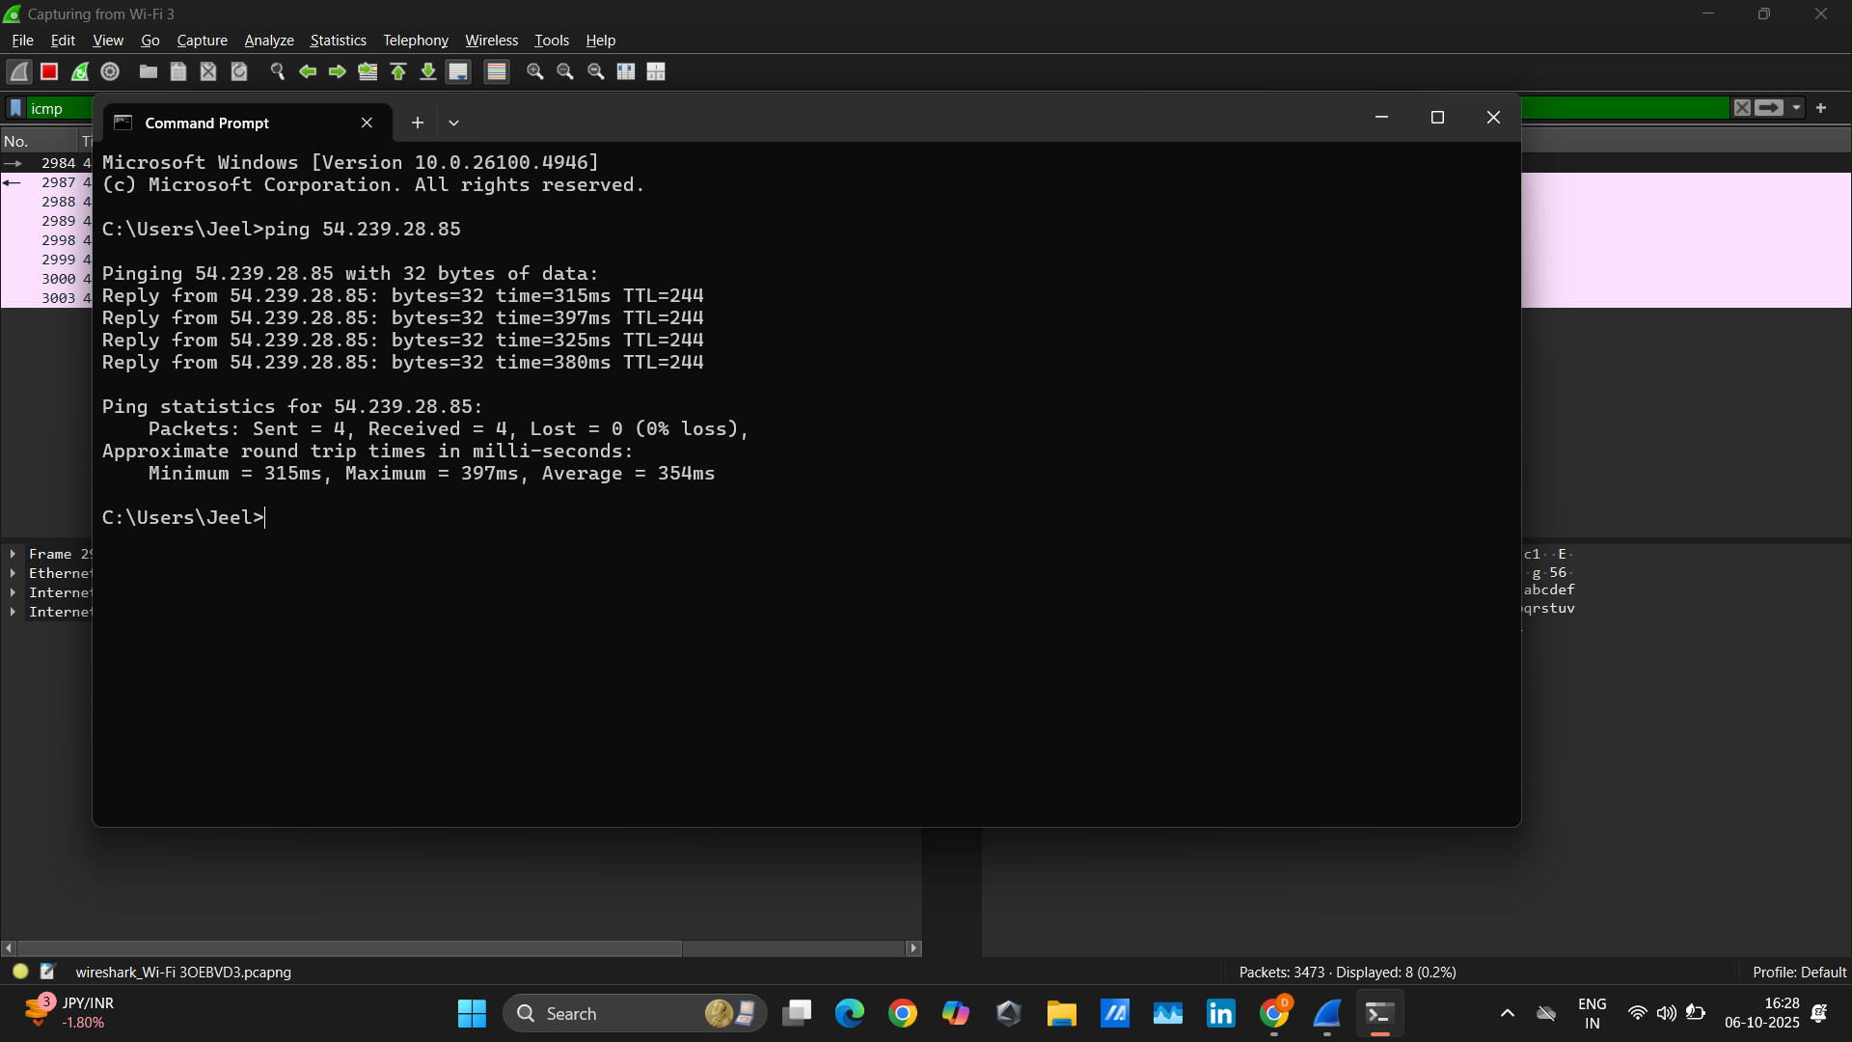

- Apply the filter :- icmp
- Observe the captured ICMP packets

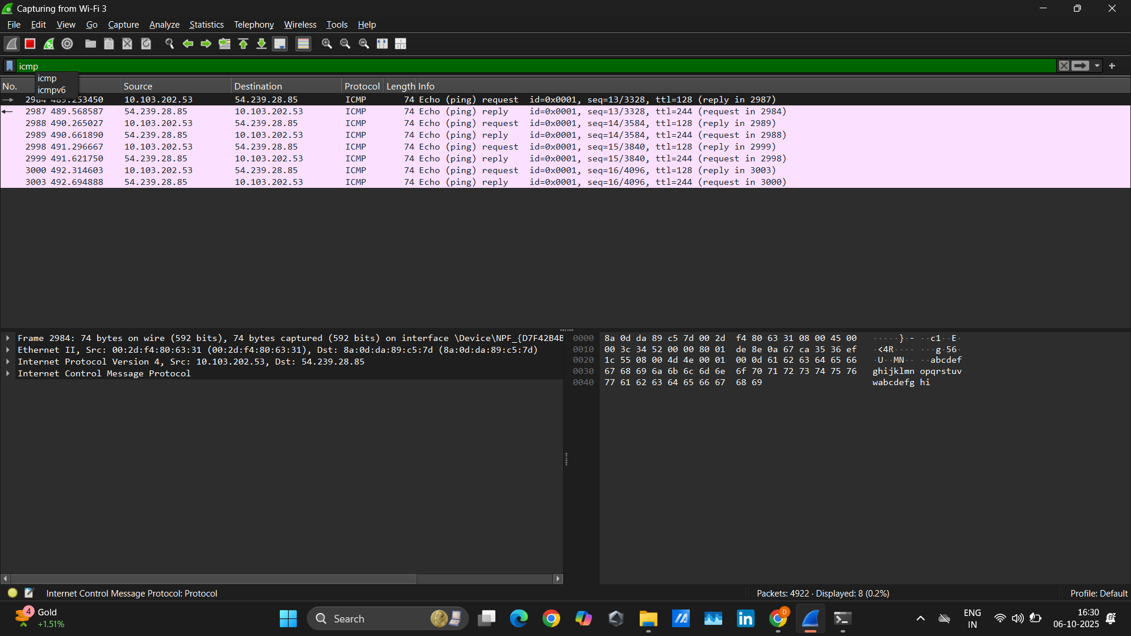

Observations :-

Ping – Part I
Parameter | Value
Destination IP address | 54.239.28.85
Number of ping messages sent | 4 (4 Echo Request packets)
Number of bytes in each ping | 74 bytes (ICMP packet length shown)
Round-trip time for each packet | Packets: Sent = 4, Received = 4, Lost = 0 (0% loss)
Minimum RTT Average RTT Maximum RTT | 315ms  354ms  397ms

Ping – Part II

Observation | Value
Destination IP address of Echo Request | 54.239.28.85
Number of Echo Request packets | 4
Number of Echo Reply packets | 4
Bytes of data in each ICMP packet | 74 bytes
Time difference between first request & first reply | Can be calculated using timestamps (first request vs first reply) — approx. visible but need exact Wireshark timestamps
Fields same in Echo Request & Echo Reply | Identifier, Checksum, Data length (because they belong to the same ping session)
Fields different in Echo Request & Echo Reply | Type (8 for Request, 0 for Reply), Sequence Number (incremented for each request)  https://chatgpt.com/share/68e47fc0-2ac4-800f-ae79-75272530bab4

